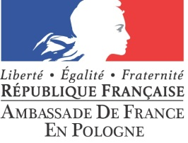

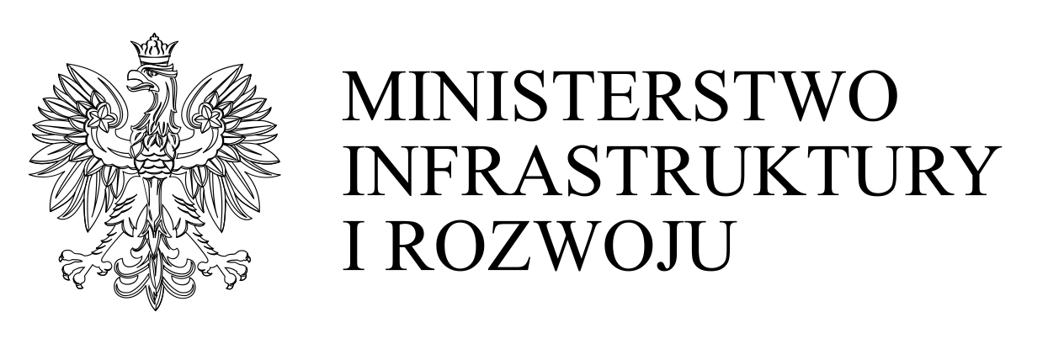

Forum franco-polonais de l’innovation et de la compétitivité
Polsko-Francuskie Forum Innowacyjności i Konkurencyjności
B2B session
13th October 2014, Ministerstwo Infrastruktury i Rozwoju
ul. Wspólna 4/2, Warszawa

REGISTRATION FORM

General information
Cluster / Enterprise Name
Cluster Coordinator’s name
Street
ZIP code
Town
Region
Telephone
Fax
E-mail
WWW
Representative (1) | Position:
Representative (1) | E-mail:
Representative (1) | Telephone:
Representative (2) | Position:
Representative (2) | E-mail:
Representative (2) | Telephone:

Total number of cluster’s members including: Number of entrepreneurs within the cluster with regard to their size:
number of entrepreneurs: |  |  | micro (1-9 employees):
number of science-technology centers: |  |  | small (10-49 employees):
business environment institutions: |  |  | medium (50-249 employees):
others: |  |  | large (<250 employees):

Range of market interactions:
 | local |  | country wide
 | regional |  | European
 | supra-regional |  | global

Sectors of business activity

Description of the cluster / enterprise (R+D+I activities, main products and services, technology available)

Cooperation types requested
common R+D project  suppliers  production capacity  Research & Development activities  subcontracting cooperation  joint venture agreement | investment objects  technical cooperation  license cooperation  manufacturing cooperation  other …………………………………………………

Description of requested types of cooperation

THANK YOU for filling in the registration form. Please send it via email to:

Grażyna Buczyńska – The Polish Agency for Enterprise Development
e-mail: grazyna_buczynska@parp.gov.pl

If you are the enterprise representative please tick the proper number of employees.

